PINE MOUNTAIN HOUSE CUP LOCATIONS
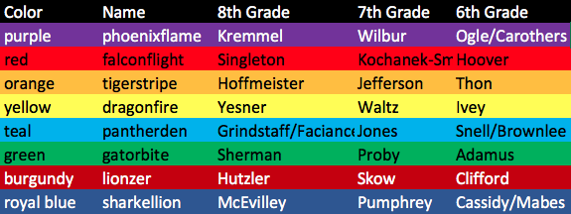

Phoenixflame (purple)
- 8th Kremmel 1712
- 7th Wilbur 1614
- 6th Ogle/Carothers 1811

Falconflight (red)
- 8th Singleton 1703
- 7th Kochanek 1721
- 6th Hoover 1816

Tigerstripe (orange)
- 8th Hofmeister 1705
- 7th Jefferson 1606
- 6th Thon 1810

Dragonfire (yellow)
- 8th Yesner 1704
- 7th Waltz 1627
- 6th Ivey 1818

Pantherden (teal)
- 8th Gindstaff/Faciane 1716
- 7th Jones 1625
- 6th Brownlee/Snell 1815

Gatorbite (green)
- 8th Sherman 1714
- 7th Proby 1615
- 6th Adamus 1904

Lionzer (Burgundy)
- 8th Hutzler 1711
- 7th Skow 1612
- 6th Clifford 1817

Sharkellion (Blue)
- 8th McEvilly 1713
- 7th Pumphrey 1613
- 6th Cassidy/Mabes 1801

