Study Guide for the End-of-Unit 1 Exam
“THE DRUMMER BOY OF SHILOH”
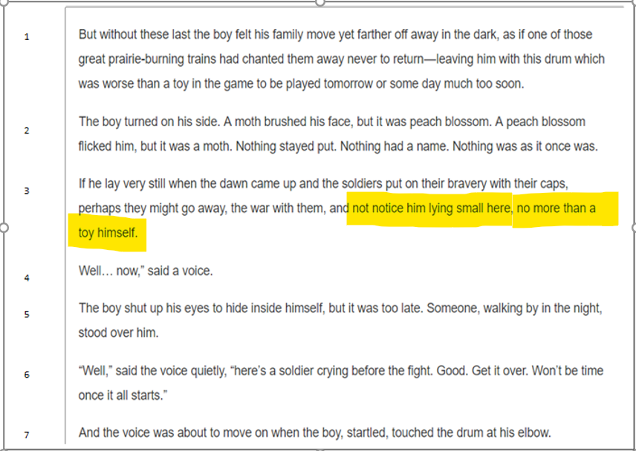

- Highlight evidence in the excerpt above that tells the reader that Joby felt like he had an unimportant role in the army. Highlighted in yellow above.

- Who was the protagonist in “The Drummer Boy of Shiloh”? (Pg.16-19) Joby, the drummer boy

How do you know? The plot was focused on him throughout the story, and the conflict happened to him.
- During which STAGE of the hero’s journey structure is the hero usually helped by someone or something? Initiation (during the challenges and trials)

- Who or what provided the most help to Joby? the general

- Using the excerpt from “The Drummer Boy of Shiloh” on Page 18 in your book, highlight evidence (and write the evidence below) that reveals Joby probably ran away from home to join the army. When the general asked Joby whether he ran away to join the army or legitimately joined the army, Joby was silent (indicating he ran away).

- How is the text below an example of the DEPARTURE STAGE? Joby shows the general through his dialogue that he is ready to begin his adventure.
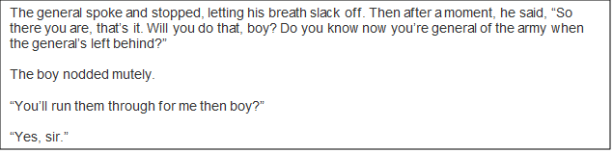

THE ODYSSEY
- Read the excerpt below. Why did Odysseus want to wait to see the Cyclops?
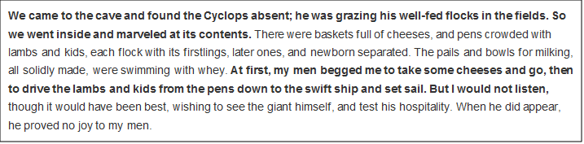
Although his men wanted him to take the food and leave, Odysseus refused. He wanted to see the one-eyed giant and “test his hospitality.” (Would he welcome him?)

- During which STAGE of the hero’s journey does the hero experience trials and challenges (Road of Trials)?
Initiation
- During which STAGE of the hero’s journey does the hero return to his ordinary life as a changed character?
Return

A WRINKLE IN TIME
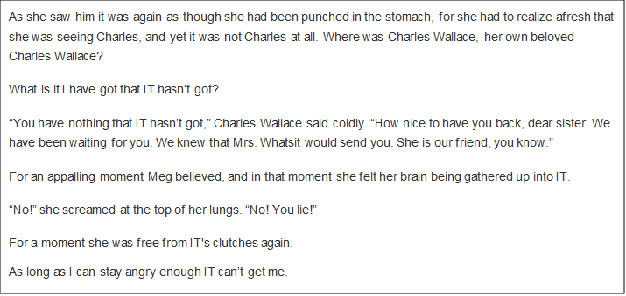
- Summarize the events in the above excerpt from A Wrinkle in Time.
Meg found her brother, but he had been brainwashed. Meg was almost brainwashed herself until she refused to be captivated by IT. She realized IT wouldn’t have control of her if she didn’t allow it.
- Since a lesson is learned during the RETURN STAGE of a hero’s journey, what part of “A Wrinkle in Time” on Page 38 shows the return stage? Write your textual evidence below:
Meg realizes the value of her family relationships, and that love will conquer IT’s control. “…she was trying to hug her father, to hug Calvin, and not let go of Charles Wallace [her brother] for one second.”

- What is the tone of the excerpt below from A Wrinkle in Time? Tone is angry.

Prove your answer to the question above with an example:
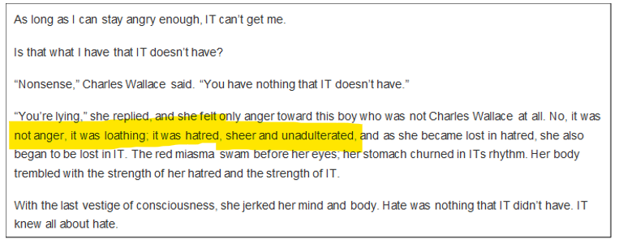

ANSWERS
ACROSS: DOWN:
3. imagery 1. conflict
5. climax 2. Character traits
6. initiation 4. Point of view
8. personal narrative 7. resolution
11. plot 9. Archetype
10. exposition
