Victorian England and Charles Dickens (GE)

A CHARLES DICKENS’ WEBQUEST
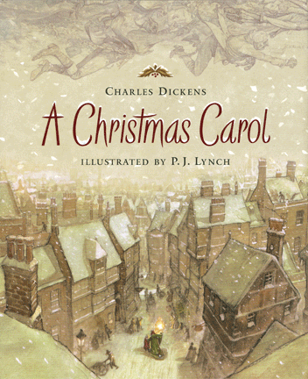

INTRODUCTION: Charles Dickens is said to be one of the greatest writers that has ever lived. Before we read one of his novels, I would like you to spend some time getting to know this man and learning what the world was like as he knew it. You will be directed to various links to answer the following questions. Have fun!

Please begin by clicking on the following link:
https://www.biography.com/people/charles-dickens-9274087
- What was the date of Charles Dickens’ birth?
- How old was Dickens when the family moved to London, England?
- What was Dickens doing right before he died?

- What famous story did Dickens write in 1843?

Go to: http://charlesdickenspage.com/dickens_london_map.html Here, you’ll find a map of London-as it was during Dickens’ lifetime. Please locate and click on Camden Town.
- Which family from A Christmas Carol lived in Camden Town?

Go to: http://www.logicmgmt.com/1876/schoolday.htm
- Please read the list of 10 rules, which were found in a typical Victorian classroom. In your opinion, which rule should still be used in schools today? Why?

Go to: http://www.victorianweb.org/history/poorlaw/dietwh.html
- Workhouses were built to house poor Victorians, who worked for a small amount of food and money. Name five foods that poor Victorians were given here.
A.
B.
C.
D.
E.

Go to: http://charlesdickenspage.com/reading_dickens.html
- In the nineteenth century, who read Dickens?

- Why is it still challenging for readers today?

Go to: http://en.wikipedia.org/wiki/Charles_Dickens
- Dickens married Catherine Thompson Hogarth in 1836. How many children did they have?

- Dickens wrote 20 major novels during his lifetime. Please write down four of them; one for each time period listed below:
1837-39:
1849-50:
1859:
1860-61:

Go to: http://www.mytimemachine.co.uk/dickens.htm

- What major event happened in 1865?
- Exactly five years later, what major event happened, and what was the date?

http://www.bbc.co.uk/schools/victorians/flash/start_flash.shtml This is a great website about Victorian children. Click on “learning” under one of these categories: work, school, play. After you watch a short video, play the game.
http://www.victorians.org.uk/ This website offers real products/toys/writing, etc. from the Victorian era. On the left side of the screen, click on “Etoys.” Play the games on this screen, or you can click on “Day in the Life.” Here, you can read journal entries from typical Victorian days.

